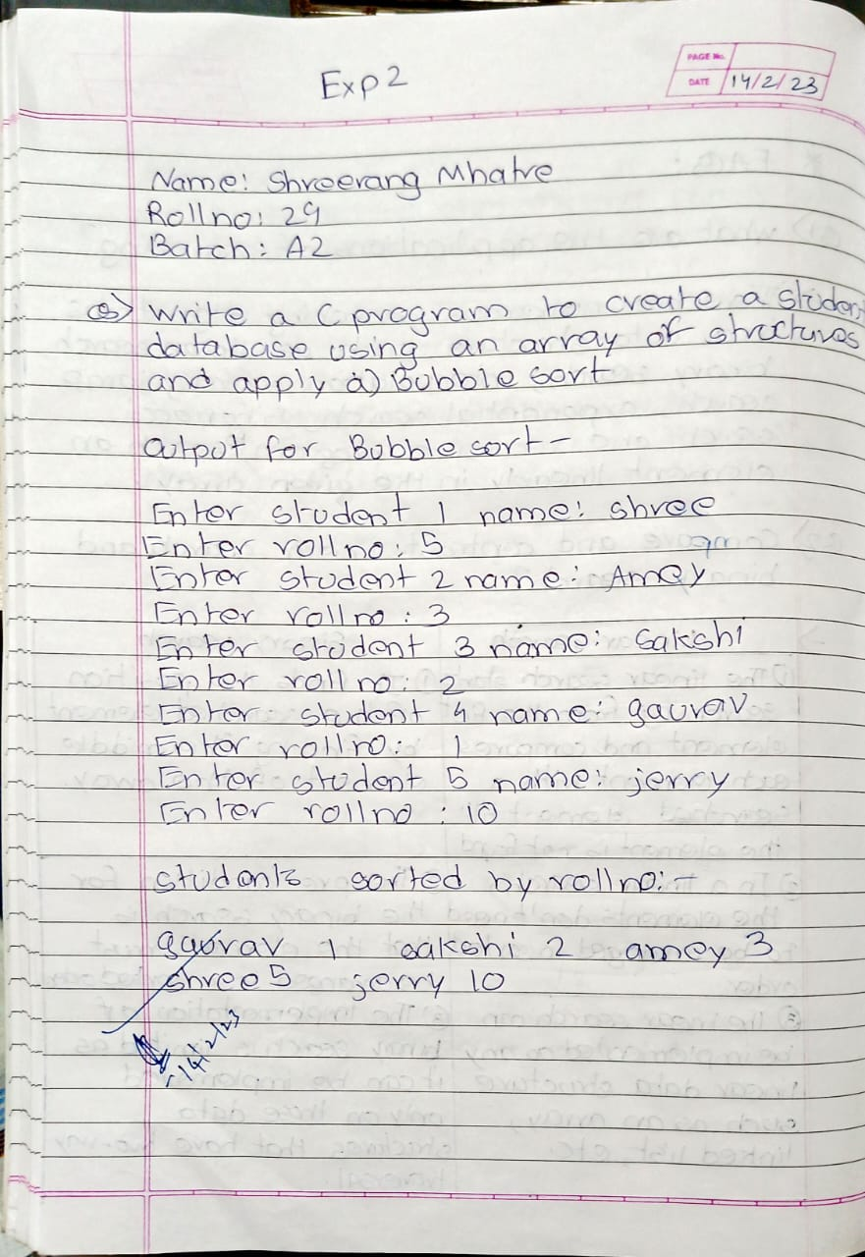

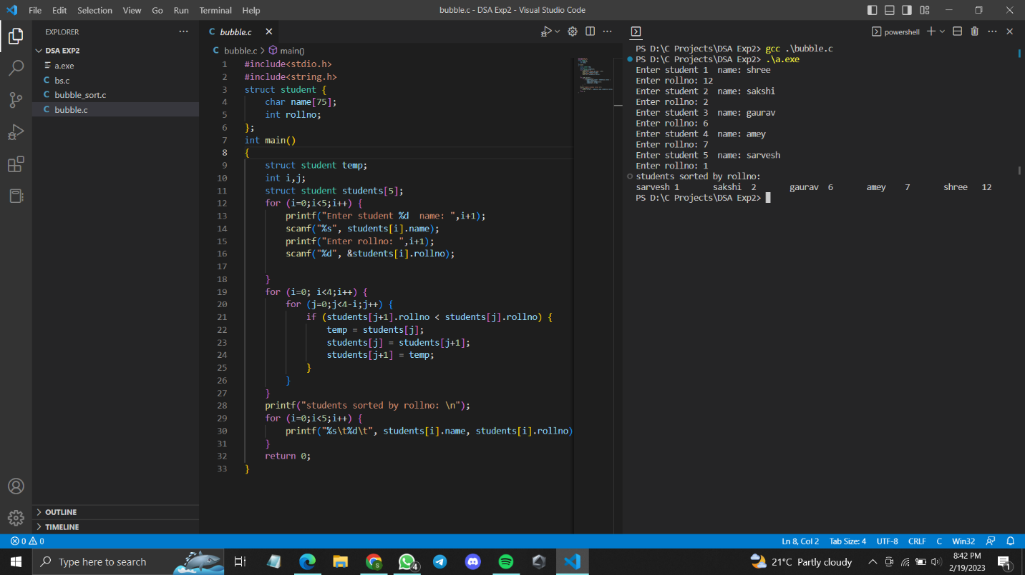

Code:

#include<stdio.h>

#include<string.h>

struct student {

char name[75];

int rollno;

};

int main()

{

struct student temp;

int i,j;

struct student students[5];

for (i=0;i<5;i++) {

printf("Enter student %d name: ",i+1);

scanf("%s", students[i].name);

printf("Enter rollno: ",i+1);

scanf("%d", &students[i].rollno);

}

for (i=0; i<4;i++) {

for (j=0;j<4-i;j++) {

if (students[j+1].rollno < students[j].rollno) {

temp = students[j];

students[j] = students[j+1];

students[j+1] = temp;

}

}

}

printf("students sorted by rollno: \n");

for (i=0;i<5;i++) {

printf("%s\t%d\t", students[i].name, students[i].rollno);

}

return 0;

}

